**INSTRUCTIONS:**

1. This task should be done individually.
2. You need to submit the soft copy of this task by the end of the class.
3. Any plagiarism and late submission will be penalized.

|  |  |  |  |
| --- | --- | --- | --- |
| **LastName** | **FirstName** | **Address** | **City** |
| Hansen | Ola | Timoteivn 10 | Sandnes |
| Svendson | Tove | Borgvn 23 | Sandnes |
| Pettersen | Kari | Storgt 20 | Stavanger |

Table 1: Persons

1. Create a table “Persons”

CREATE TABLE PERSONS

(LAST_NAME VARCHAR(30),

FIRST_NAME VARCHAR(30),

ADDRESS VARCHAR(40),

CITY VARCHAR (20));

1. Insert data based on the above table.

INSERT INTO PERSONS VALUES

('Pettersen','Kari','Storgt 20','Stavanger');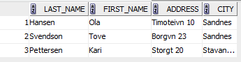

3) Display your table

4) Display only first name and last name.

SELECT Last_Name,First_Name FROM Persons

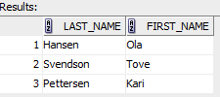

5) Display records for persons live in Pahang.

SELECT * FROM Persons

WHERE City='Pahang'

Result : null. Nobody live at Pahang in the table

6) Display record where first name is Hansen and last name is Ola.

SELECT * FROM Persons

WHERE first_name='Hansen'

OR last_name='Ola'

7) Display names order by last name.

SELECT * FROM Persons

ORDER BY Last_Name

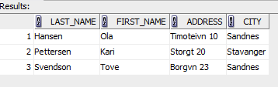

8) Insert following data ‘4’,'Nilsen', 'Johan', 'Bakken 2', 'Stavanger'

Value insert ada 4 sahaja. Tapi soalan nak 5. Salah

9) Display records with city equal to Sandnes using command like.

SELECT * FROM Persons

WHERE City LIKE '%s'

Function LIKE baca dari belakang

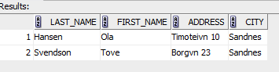

10) Display records for person last name equal to Hansen and Pettersen using command in.

SELECT * FROM Persons

WHERE Last_Name IN ('Hansen','Pettersen')

